 | Autumn term 1 | Autumn term 2 | Spring term 1 | Spring term 2 | Summer term 1 | Summer term 2
 | We use core texts to explore the history element of Understanding the World.
EYFS | Nursery  Begin to make sense of their own life-story and family’s history.  They will explore their own family unit and recall memories from the past, including times of celebration.
 | 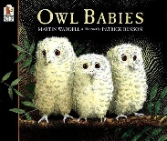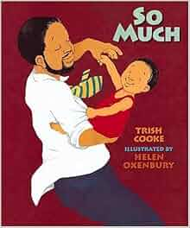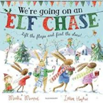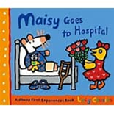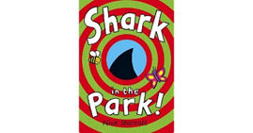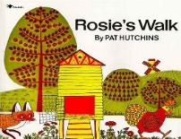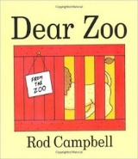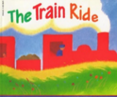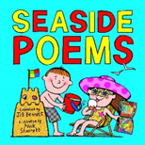
Reception
Name and describe people who are familiar to them
Comment on images of familiar situations in the past.
Compare and contrast characters from stories, including figures from the past.
Early Learning Goal – Past and Present
Children at the expected level of development will:
- Talk about the lives of the people around them and their roles in society;
- Know some similarities and differences between things in the past and now, drawing on their experiences and what has been read in class;
- Understand the past through settings, characters and events encountered in books read in class and storytelling.
 | 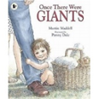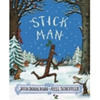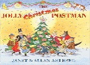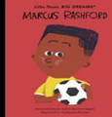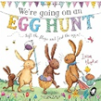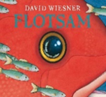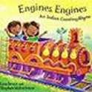
Year 1 | Changes within living memory: toys and games  Are Toys better now or in the olden days? | Lives of significant individuals: David Attenborough, Greta Thunberg, Jane Goodhall  Who has done more for our World?
Year 2 | Changes within living memory: The Great Fire of London  What good came out of the Great Fire of London? |  |  |  | Local History: George Stephenson and the Rainhill Trials  Why is Newton-le-Willows an historic town?
Year 3 | The Stone Age  Would you prefer to live in the Stone Age, Bronze Age or Iron Age? |  | The Romans  What did the Romans do for us?
Year 4 | Anglo-Saxons and the Vikings  Would you rather be an Anglo-Saxon or a Viking? |  |  |  | The Ancient Egyptians  How did the Ancient Egyptians survive in the desert?
Year 5 |  | World War II/  Local History  What was the impact of WW2 on British people? |  |  |  | The Ancient Greeks  What did the Greeks ever do for us?
Year 6 | The Mayans  How were the Maya ahead of their time |  | The Tudors  Was everything about the Tudors terrible?

