DIY WORLD BOOK DAY IDEAS
Our reading ambassadors have decided that they would like to embrace the theme of sustainability this World Book Day.
Can you recycle an old costume?
Can you make your own from recyclable materials?
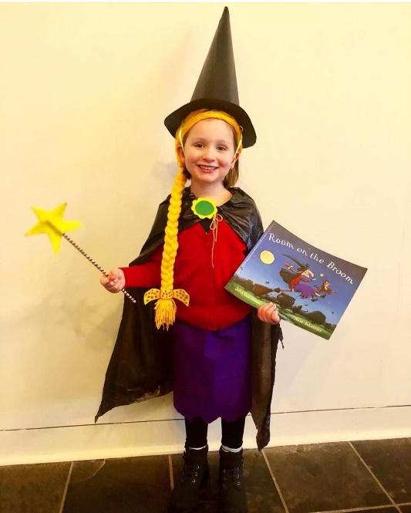
Why not visit your local charity shop?
Keep it simple and make it fun!
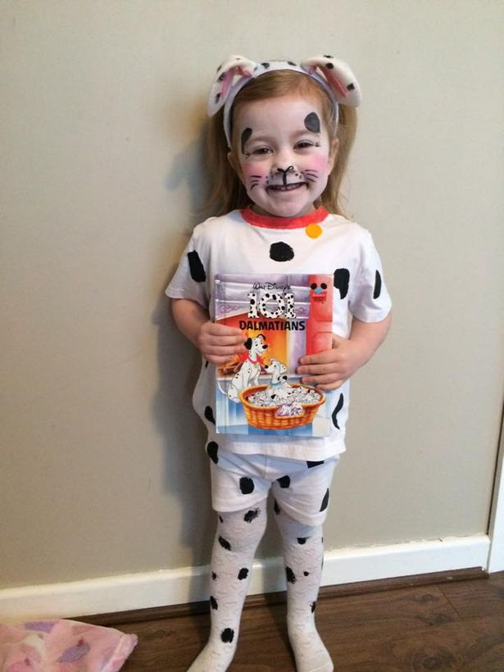
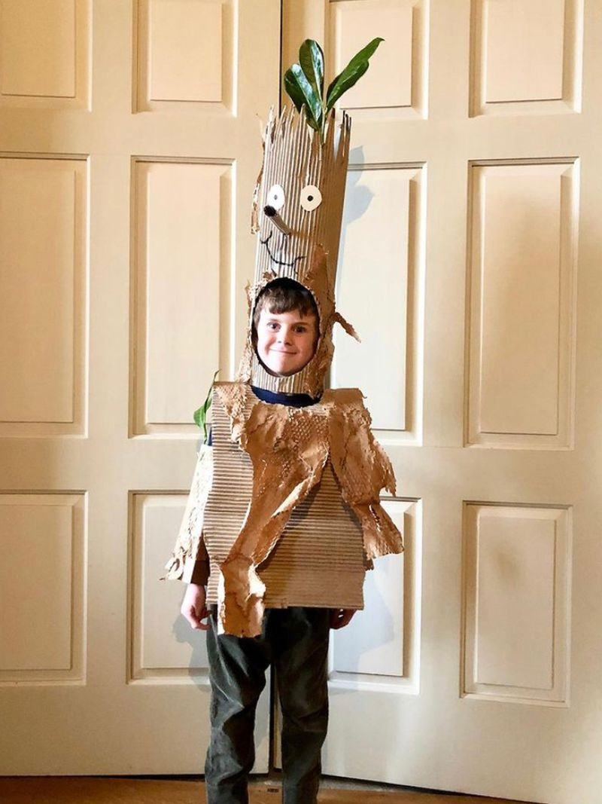
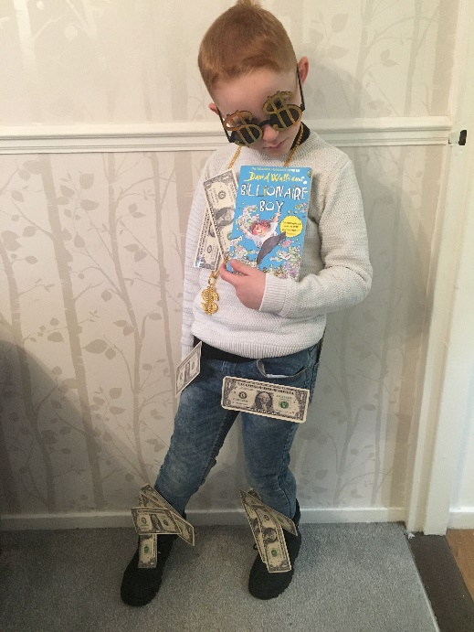
Here are some ideas.

