Name: ______________________________ Date:________________________
Shape Investigation (2D and 3D shapes)
- Find an object.
- Is it a 2D or 3D shape?
- Describe the properties of the object.
Draw and name the object | This object is a ______ shape |  | The properties of the object
Filing Cabinet 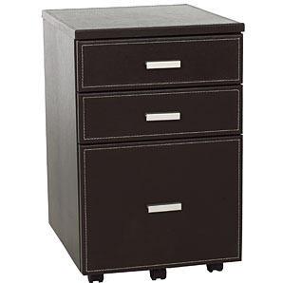 | 2D | 3D | _________vertices __________edges ___________faces
Clock  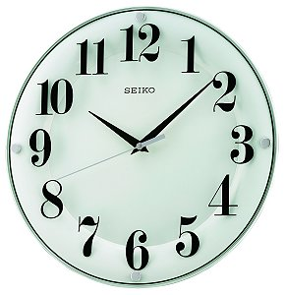 | 2D | 3D | _________vertices __________edges ___________faces
Globe  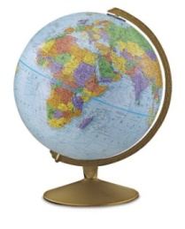 | 2D | 3D | _________vertices __________edges ___________faces
 | 2D | 3D | _________vertices __________edges ___________faces
 | 2D | 3D | _________vertices __________edges ___________faces
 | 2D | 3D | _________vertices __________edges ___________faces
 | 2D | 3D | _________vertices __________edges ___________faces
 | 2D | 3D | _________vertices __________edges ___________faces
 | 2D | 3D | _________vertices __________edges ___________faces
 | 2D | 3D | _________vertices __________edges ___________faces

