Lyme CP Progression in Subtraction
Early Years | Children begin to compare amounts and discuss the language ‘less’ or ‘fewer’. Using practical equipment, they begin to explore the concept of number in small steps building to 20 and learn to take away 1 ( 1 less) using the correct mathematical symbol. 3 – 1 = 2  7 – 1 = 6  15 – 1 = 14  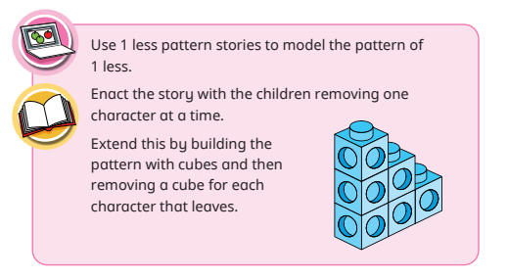  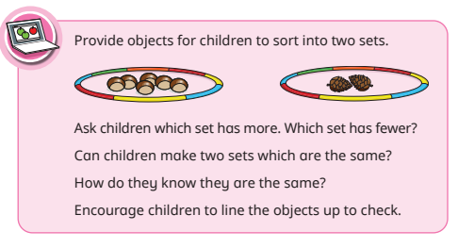  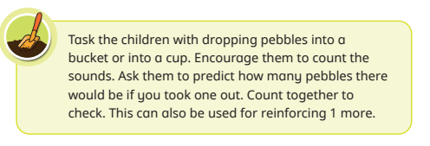
12 – 1 = 11 |  | Year Three
Missing number problems e.g. 7 = □ - 9; 20 - □ = 9; 15 – 9 = □; □ - □ = 11; 16 – 0 = □  Use concrete objects and pictorial representations. Understand subtraction as take-away:  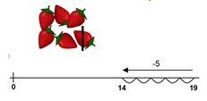  Understand subtraction as finding the difference:  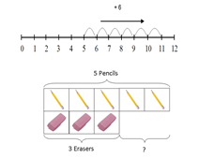  The above model would be introduced with concrete objects which children can move before progressing to pictorial representation.  The use of other images is also valuable for modelling subtraction e.g. Numicon, bundles of straws, Dienes apparatus, multi-link cubes, bead strings  Use ten frames and rekenreks to develop non counting by ones method.  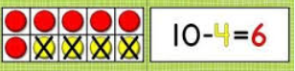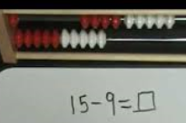 | Missing number problems e.g. 52 – 8 = □; □ – 20 = 25; 22 = □ – 21; 6 + □ + 3 = 11  It is valuable to use a range of representations (also see Y1). Continue to use number lines to model take-away and difference. E.g.  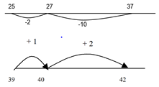  The link between the two may be supported by an image like this, with 47 being taken away from 72, leaving the difference, which is 25. 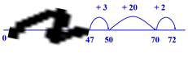  The bar model should continue to be used, as well as images in the context of measures.  Towards written methods  Recording subtraction in expanded columns can support understanding of the quantity aspect of place value and prepare for efficient written methods with larger numbers. The numbers may be represented with Dienes apparatus. E.g. 75 – 42  Use of number square to add tens and ones.  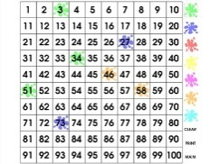 | Missing number problems e.g. □ = 43 – 27; 145 – □ = 138; 274 – 30 = □; 245 – □ = 195; 532 – 200 = □; 364 – 153 = □  Mental methods should continue to develop, supported by a range of models and images, including the number line. The bar model should continue to be used to help with problem solving (see Y1 and Y2).  Children should make choices about whether to use complementary addition or counting back, depending on the numbers involved.  Written methods (progressing to 3-digits)  Introduce expanded column subtraction with no decomposition, modelled with place value counters (Dienes could be used for those who need a less abstract representation)  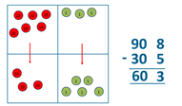  For some children this will lead to exchanging, modelled using place value counters (or Dienes).  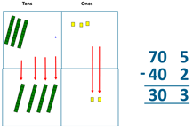  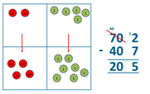  A number line and expanded column method may be compared next to each other.  Some children may begin to use a formal columnar algorithm, initially introduced alongside the expanded method.
Year Four | Year Five | Year Six
Missing number/digit problems: 456 + □ = 710;  1□7 + 6□ = 200; 60 + 99 + □ = 340; 200 – 90 – 80 = □; 225 - □ = 150; □ – 25 = 67; 3450 – 1000 = □; □ - 2000 = 900  Mental methods should continue to develop, supported by a range of models and images, including the number line. The bar model should continue to be used to help with problem solving. Children should make decisions about most efficient methods eg 2000-1999  Written methods (progressing to 4-digits)  Expanded column subtraction with decomposition, modelled with place value counters, progressing to calculations with 4-digit numbers.  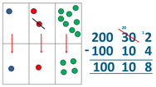  If understanding of the expanded method is secure, children will move on to the formal method of decomposition, which again can be initially modelled with place value counters.  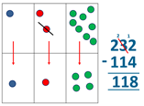 | Missing number/digit problems: 6.45 = 6 + 0.4 + □; 119 - □ = 86; 1 000 000 - □ = 999 000; 600 000 + □ + 1000 = 671 000; 12 462 – 2 300 = □  Mental methods should continue to develop, supported by a range of models and images, including the number line. The bar model should continue to be used to help with problem solving. Children should make decisions about most efficient methods eg 2000-1999  Written methods (progressing to more than 4-digits)  When understanding of the expanded method is secure, children will move on to the formal method of decomposition, which can be initially modelled with place value counters. 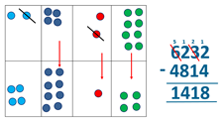  Progress to calculating with decimals, including those with different numbers of decimal places. | Missing number/digit problems: □ and # each stand for a different number. # = 34. # + # = □ + □ + #. What is the value of □? What if # = 28? What if # = 21  10 000 000 = 9 000 100 + □  7 – 2 x 3 = □; (7 – 2) x 3 = □; (□ - 2) x 3 = 15  Mental methods should continue to develop, supported by a range of models and images, including the number line. The bar model should continue to be used to help with problem solving.  Written methods  As year 5, progressing to larger numbers, aiming for both conceptual understanding and procedural fluency with decomposition to be secured.  Continue calculating with decimals, including those with different numbers of decimal places.

