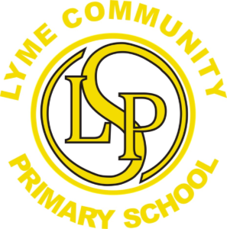

Please insert your child’s photo here.

Name: ___________________________

At Home.

The people in my family are…

______________________________________

My pets are…

______________________________________

At home I like to …

______________________________________

I can draw a picture of myself…

My favourite things.

My friends are called…

My favourite foods are…

________________________________________________

My favourite songs are…

My favourite stories are…

________________________________________________

My favourite toys are…

________________________________________________

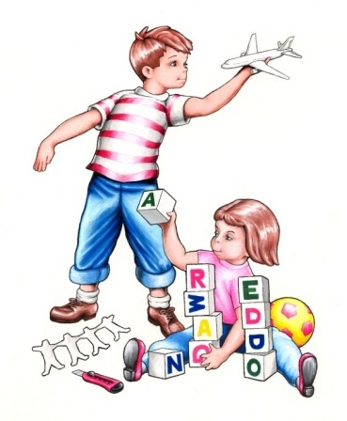

Things that worry me.

I get upset when…

________________________________________________

I am scared when…

________________________________________________

I do not like…

________________________________________________

Foods, I do not like are…

________________________________________________

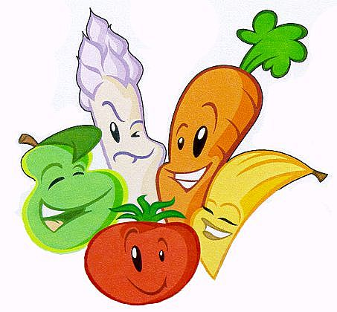

Look what I can do.

I can put on my own coat… Yes/ no

I can dress myself for school… Yes/ no

I can go to the toilet by myself… Yes/ no

I can use a knife and fork… Yes/ no

I can recognise my own name… Yes/ no

I can write my own name by myself…

I am used to being looked after by Mummy/Daddy/

Grandparents/Childminder/other____________________

I have been to nursery/playgroup_____________________

The name is______________________________________

What do you hope your child will gain from their early years experience? ________________________________________________________________________________________________

Is there anything else you think would be beneficial to tell us about your child? ________________________________________________________________________________________________
Please return on your first day of school 😊

